RESOURCES

WEBSITES
Learning from Washington’s Adverse Childhood Experiences Story: https://www.doh.wa.gov/ (then search ACEs)
Highlights how Washington supported state-level ACE data collection, how data were used to inform
prevention efforts, and provides examples of the state’s next steps in preventing abuse and neglect.

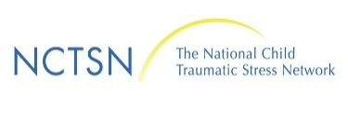
National Child Traumatic Stress Network: https://www.nctsn.org/
A result of an Act of Congress 2005, in response to 9/11 and the national trauma experienced by children affected by this act of terrorism.
*An Excellent resource

CDC: http://www.cdc.gov/violenceprevention/childmaltreatment/index.html

Edutopia: http://www.edutopia.org
Transforming K-12 so students thrive into adulthood.
Trauma and Learning Policy Initiative: http://massadvocates.org/tlpi/
Helping traumatized children learn: a nationally recognized collaboration between Massachusetts Advocates for Children and Harvard Law School

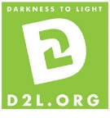
EDUCATION
Darkness to Light’s Stewards of Children Training
A national evidence-informed child sexual abuse prevention training, providing steps that
enable adults to protect the children in their lives and in youth serving organizations.

Find a facilitator led training near you: https://www.d2l.org/education/stewards-of-children/facilitator-led/
Take the online training: https://www.d2l.org/education/stewards-of-children/online/

BOOKS
The Deepest Well, Dr. Nadine Burke Harris
Reaching and Teaching Children Effected by Trauma, Barbara Sorrells
The Child Who was Raised as a Dog, Dr. Bruce Perry

OTHER
TED Talk on Trauma by Dr. Nadine Burke Harris

Movie: Paper Tigers – A powerful documentary about Lincoln High School in Walla Walla that trained all staff to be trauma informed. The documentary follows several students over a course of a year as the impact unfolds.

Washington State Department of Social and Health Services
1-866-END HARM (1-866-363-4276) Mandatory Reporters

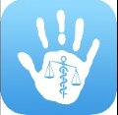
Free app for smart phones: ChildProtector - an outstanding resource for child abuse screening. Designed to help CPS, law enforcement and medical personnel evaluate children. The app includes educational videos, teaching and forensic decision making tools to help guide further testing and referral.

